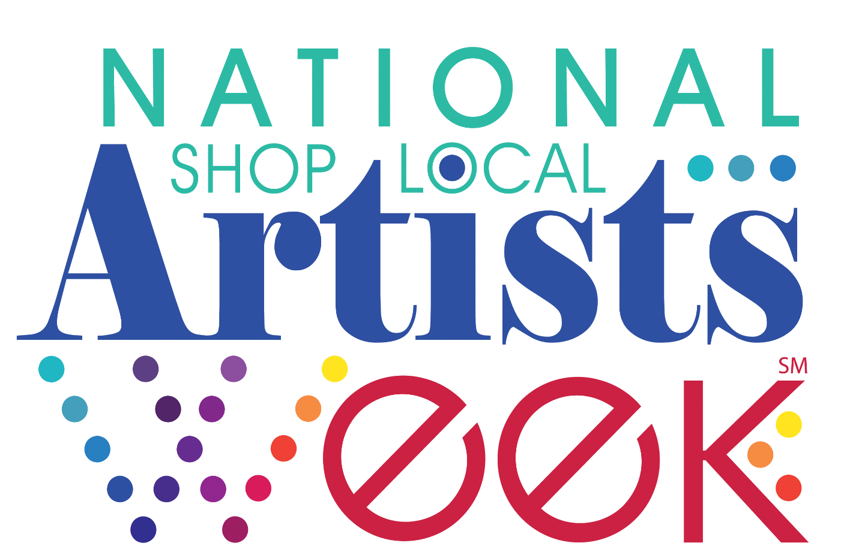

www.ShopLocalArtistsWeek.org

HOW TO PARTNER
Happy National Shop Local Artists Week!

Shop Local Artists Week began as a local initiative sponsored by the Northshore Cultural Economy Coalition (CEC)—located in Slidell, Louisiana—in December of 2016. It included a small event at the East St. Tammany Chamber of Commerce’s first floor Art Marketplace, showcasing visual art and artists, as well as local authors with a book signing and reading event. Shortly after, Northshore CEC Chair Kim Bergeron presented a proposed resolution to Louisiana State Senator Sharon Hewitt, asking for her support to recognize Shop Local Artists Week as a statewide initiative beginning in 2017. Senator Hewitt enlisted the support of Representative Greg Cromer, and the two were instrumental in pushing the resolution through. In April 2017, the resulting Concurrent Resolution, SCR20, was adopted with unanimous votes in both the Senate and the House. The resolution deemed the first week of December as Shop Local Artists Week and promoted the economic impact of the arts. Read more of Northshore CEC’s leadership in Shop Local Artists Week on ARTSBlog.
For 2018, in collaboration with the Northshore CEC and Americans for the Arts, we ask the entire creative field to join together on December 1 – 7, 2019 in communities across the country to promote the sales of local artists’ work and to promote to all consumers that all forms of art—including tickets to events and organization memberships—make great holiday gifts.
Over the course of the week, we hope that the creative field can join together with a common message: artists are essential to our economies. We have compiled resources available to help National Shop Local Artists Week Partners celebrate. Overall, we hope that throughout the country individuals, organizations, and communities can accomplish three goals:

1.) Celebrate. Whether big or small, host celebrations across the country. Utilize shared messaging and branding to be a part of something bigger.

2.) Advocate. Work with your elected officials and decision makers to share the invaluable impact artists have in our communities and economies. Whether a mayor, governor, or U.S. Congressman, check out compelling research, sample resolution, and customizable op-eds to send to your local newspapers to help bring them on board.

3.) Share your story. Participate in the social media campaign to bring national visibility to the issue of supporting and celebrating local artists. This is your chance to tell your own personal story of the transformative power of the arts.

Want to join in the celebration? Let us know by emailing Advocacy@artsusa.org for more information on how to get started. We are here to help and look forward to joining together in celebration.

Please save the dates for upcoming National Shop Local Artists Week celebrations:
- December 6 – 12, 2020
- December 5 – 11, 2021

BRANDING
The brand for National Shop Local Artists Week was created by the Northshore Cultural Economy Coalition in 2016, and the generic branding is now being provided to the field for use free of charge. The intention for shared branding of celebrations across the nation is to unify the creative field and demonstrate together the transformative power of the arts in our communities’ economies and jobs. The hope with a unified brand will become synonymous with an annual event in every community across the country celebrating the impact of our work.
The logo is evergreen and free of use for you to use in your materials.
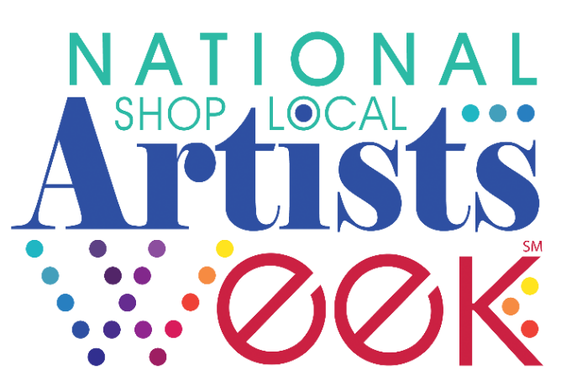

WEBSITE
Like the shared logo, the shared website URL has been created unified branding purposes. Any and all organizations or individuals celebrating National Shop Local Artists Week, may use this website domain name free of charge. The domain redirects to a page which hosts information relevant to the current year’s celebration.
The intention for a shared website is to direct any interested party to find more information about the national celebration, ways to participate, or anything happening locally in their community. To achieve this goal, depends on your input of local events and the sharing of the website throughout your branding and communications.

Website use guidelines:
- The website is intended for use by anyone who wishes to celebrate National Shop Local Artists Week.
- The URL should be written in lowercase font with the exception of the first letter of each word, as such: “www.ShopLocalArtistsWeek.org”
HOSTING A CELEBRATION
Examples of National Shop Local Artists Week celebrations are:

- Holiday Art Festival or Market
- Coordinated gallery openings and exhibitions
- Live entertainment in numerous locations
- Live artist demos, including workshop showcases
- Book readings and signings
- Dance exhibitions
- Film Fest screenings
- Healing arts expo
- Concerts
- Theatre events
- Poetry Out Loud event
- Cooking demos during the fest and/or restaurants offering artsy dinners all week long
- “Adopt an Artist” initiative for businesses that are not galleries – for visual arts and/or
- book signings
- Opportunities for museums, galleries, theatres, art instructors to market and sell
- memberships and/or event tickets and workshop gift certificates.
- Promote the experience of creating art and memories together!

PROMOTING A CELEBRATION
Celebrating is an integral part of National Shop Local Artists Week. Whether hosting a specific event in honor of the week or leveraging an existing event to bring forward the message of the week, be sure to tell your community what is going on.
When hosting an event, you are encouraged to utilize the assets of the national celebration in your favor. Have you thought about the following?
- Be sure to use the logo in your marketing materials to signify that your event is part of a larger national celebration. Do you have a website or poster to insert the logo?
- At your event share the latest research and key messaging about the economic impact of the arts with your community members. Could you place a poster in your space or ad in key community locations and publications?
- Invite key decisionmakers from your community to your event. Is there an opportunity for them to speak about the power of the arts?
- Tell your local media. Have your event listed for all community members to attend. Could you consider writing an Op-Ed in your local paper about the power of the arts and the national celebration?
- Share out what you are doing with our field. When tweeting or posting on social media, be sure to use the hashtag #ShopLocalArtistsWeek. Also, check out the #ShopLocalArtistsWeek feed to see what others are doing around the country.
- Tell us about it! We are keeping a log of events and their impact. Be sure to send us an email after the event at Advocacy@artsusa.org.
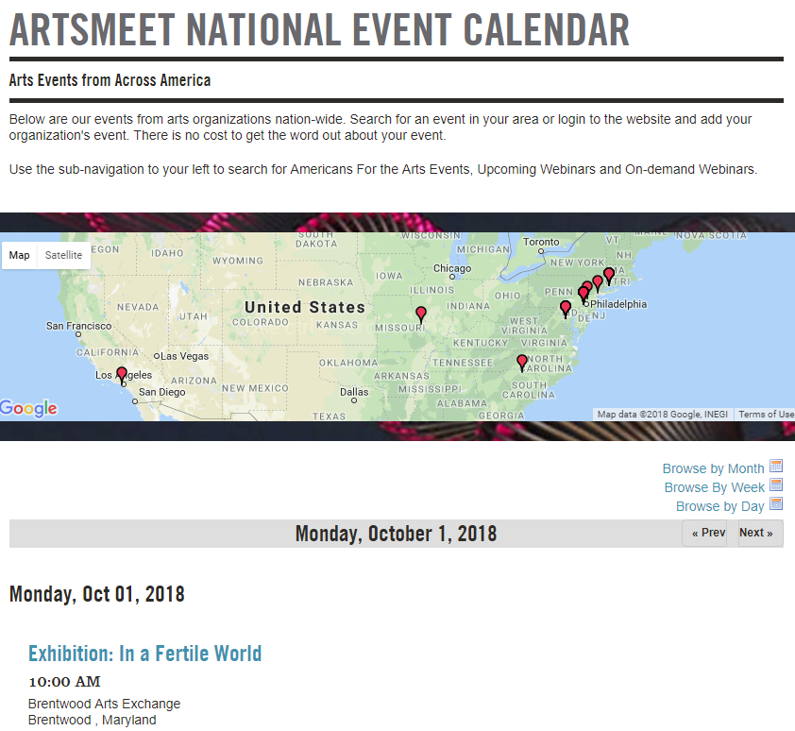
EVENTS MAP
Once all of the details are worked out for your event, be sure to register the event on ArtsMeet. This online events map will host information on events throughout the country.
To register your event, please follow this easy process:
- Visit ArtsMeet National Event Calendar.
- Create an account.
- Provide the title, description, location, etc.
- Submit.
- If you want to expedite the process or have any questions, email Advocacy@artsusa.org
ArtsMeet is found here.

ADVOCACY
An essential part of National Shop Local Artists Week is leveraging the celebration to engage decision makers. In the following section, we have compiled a number of resources to aid in this endeavor for advocacy novices and experts alike.

SAMPLE RESOLUTION
A simple and effective way to leverage is to replicate similar resolutions to the one that Louisiana state legislature passed to municipal and state governments across the country. Whether working with your chamber of commerce, the city’s mayor, or the state governor, you can partner with them to use their influence to bring attention to the cause.
Be sure to download the sample resolutions for use with your elected or educational officials. Consider the following tips:
- Download the resolution from www.NationalShopLocalArtistsWeek.org
- Customize it to be relevant to your city, county, state, etc. Be as specific as possible.
- Submit it to your official’s website, or staff member who is responsible for resolutions. You may start off by calling to ask who the appropriate contact may be.
- Provide sample text and make yourself available as a resource for more information.
- Be concise. Don’t send a full report, but instead send the relevant statistics with a link to where they can find more.
- Follow up. Call or email to ensure the resolution is being process in time for the celebration.
- Obtain a hard copy of the resolution for your records. Scan and upload it to your website or social media.
- Tell others about the resolution. You may issue a press release or include it in a newsletter.
- Thank the official and staff members for their help in making it happen.
If you are successful in this effort, please tell us and send a digital copy or photo of the resolution to Advocacy@artsusa.org

CRAFT YOUR CASE
For those just starting down the path of arts advocacy, you need to craft a compelling narrative in support of the arts to decision makers. Consider the following as you craft your “arts elevator pitch”:
- Your Audience
  - Who are they?
  - What motivates them?
  - Where do they get their information?
  - Why are these issues important to them?
  - What you want them to do?
- Your Framing:
  - Frames set off our values and help us decide what information is relevant to us and what is not.
    - What motivates them?
    - What frustrates your them?
- Your Messaging:
  - What personal story would work the best to tell?
  - What compelling data would ground your message?
  - Which engagement strategy do you think will work best?
    - Example: Invite them to speak at an event
- Your Ask
  - Clearly state what you want them to do.
  - How will you know that you have achieved the goal?

For more information, please contact Advocacy@artsusa.org.

LOCAL OP-EDS
- Click here for a template op-ed for you to send to your local media outlets.
- Customize your op-ed to be relevant to your city, county, state, etc. Be as specific as possible.
- Be concise. Remember: heartwarming story + hard-hitting data = successful advocacy.
- Submit it through the VoterVoice system. A copy of your op-ed will be e-mailed to you. Consider scan and uploading it to your website or social media.
- Provide sample text and make yourself available as a resource for more information.
- Follow up. Call or email to ensure your op-ed has been received is being process in time for the celebration.
- Tell others to submit op-eds in support of National Shop Local Artists Week.
- If published, Thank the newspaper editor and staff members for their help in making it happen.
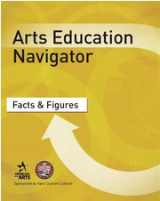
ADVOCACY E-BOOKS
For those who are more seasoned advocates, be sure to check out this series of e-books to help you refine your skills.
Though centered in arts education, the Arts Education Navigator is a valuable and transferrable resource for advocates in all interest areas. It is compiled of four e-books which help you understand the basics, use the data, craft your message and mobilize others.
- Getting Started: Explore the who, what, where, when, why, and how of arts education.
- Facts & Figures: Discover the data on the benefits and decline of arts education.
- Making the Case: Learn how to effectively craft your message in your advocacy work to key decision makers.
- Mobilizing Support: Focus on the ins and outs of campaign crafting and organizing for change.
Reach Out to Community Partners
Strengthen your National Shop Local Artists Week celebration by collaborating with community partners to co-host with you. Ideas for partners are:
- Chamber of Commerce;
- League of Municipalities;
- Main Street Alliance;
- Department of Tourism;
- Community Development Associations;
- State Arts Advocacy Organization;
- State Arts Agency;
- Local Arts Agency;
- Arts and Business Council;
- School District;
- And more!

SHARE YOUR STORY
An essential part of National Support Local Artists Week is visibility. We encourage all arts supporters to participate in the visibility efforts of the campaign to ensure a strong voice for our field across the country.
Whether you are an individual or an organization, you can participate in sharing your story on social media using hashtag #ShopLocalArtistsWeek.
Participate by sharing your story on any of the following social media platforms:
- Facebook: www.Facebook.com
- Twitter: www.Twitter.com
- Instagram: www.Instagram.com
Be sure to spread the news on Twitter by sharing a post ahead of time or retweeting others’ posts.
Example Post:
Save the date: National Shop Local Artists Week is Dec. 1-7. Host an event, celebrate artists nationwide! #ShopLocalArtistsWeek

Tips for promoting the campaign:
- Send a promotional tweet to your followers ahead of time.
- Pre-write and schedule your tweets using TweetDeck or other scheduling platforms.
- Tag other people or organizations when mentioning them specifically.
- When uploading a photograph, be sure to tag people in the photo (using the “who is in this picture function).
- Be sure to use shortlinks through bit.ly.
- Like and Retweet or share others’ posts.
- ALWAYS use the hashtags #ShopLocalArtistsWeek.

Looking for something to post? Share your own personal story or that of your organization, participate in the designated social media campaign, or post some of the resources mentioned in the previous section of this packet.

